**For Deploying Java Web Application in Amazon Ec2 using Eclipse**

Lab-2 A-Configuration of aws with eclipse

Step1-First you have to install the AWS toolkit for eclipse plugin

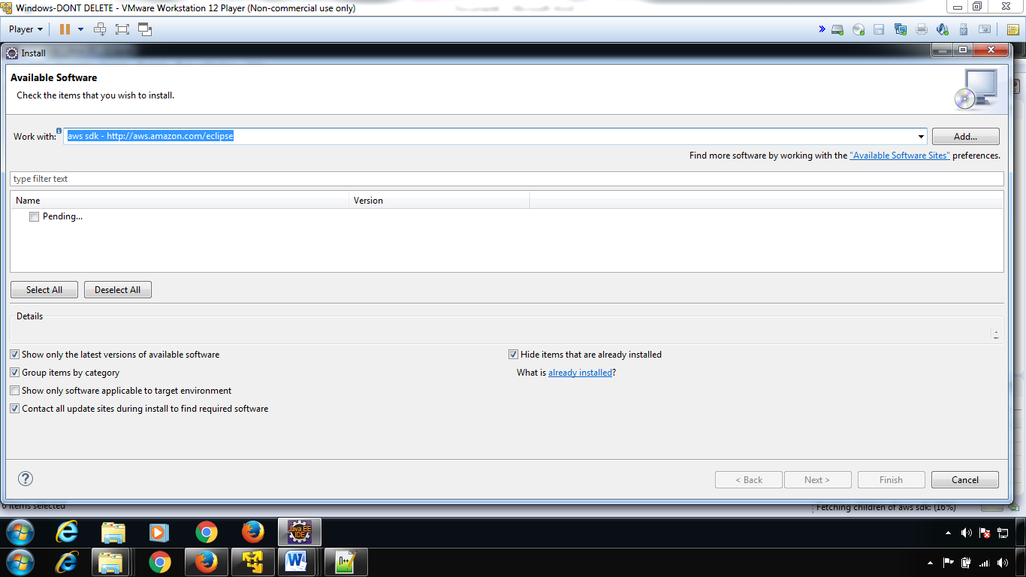

Step-2: creating a new access key( to get secrect access key)----By default---No secret access key

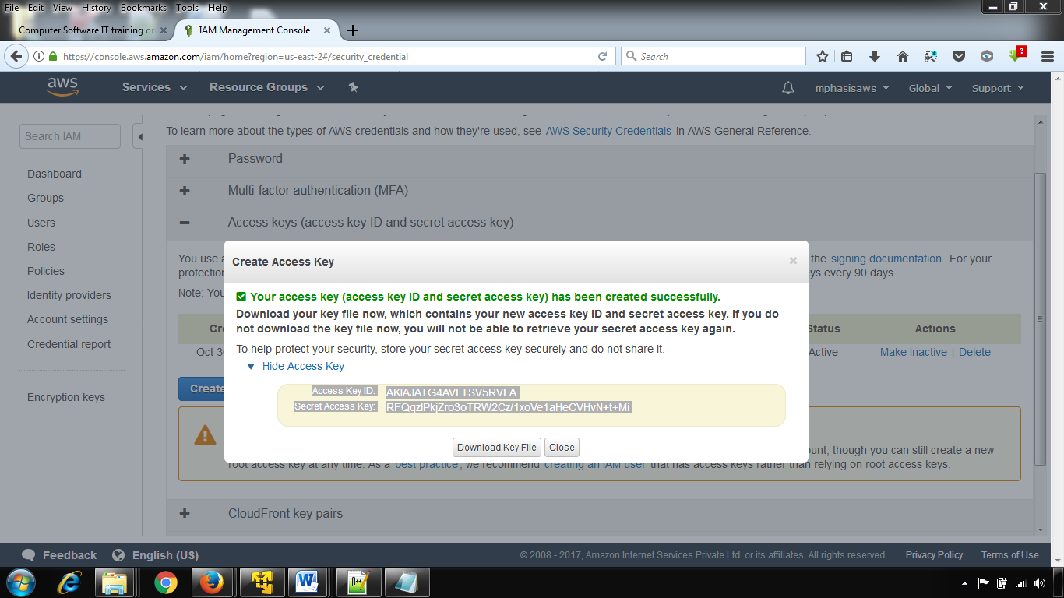

Step-2

* Windows --> Preferences --> select AWS Toolkit and Fill the fields according to your amazon ec2 account
* Give your name to Account Name (Not Necessary), 3 inputs---acesskey+secret accesskey+account id
* In the optional configuration (Expand it) give account id (exact value) to that field
* 3 inputs---acesskey+secret accesskey+account id

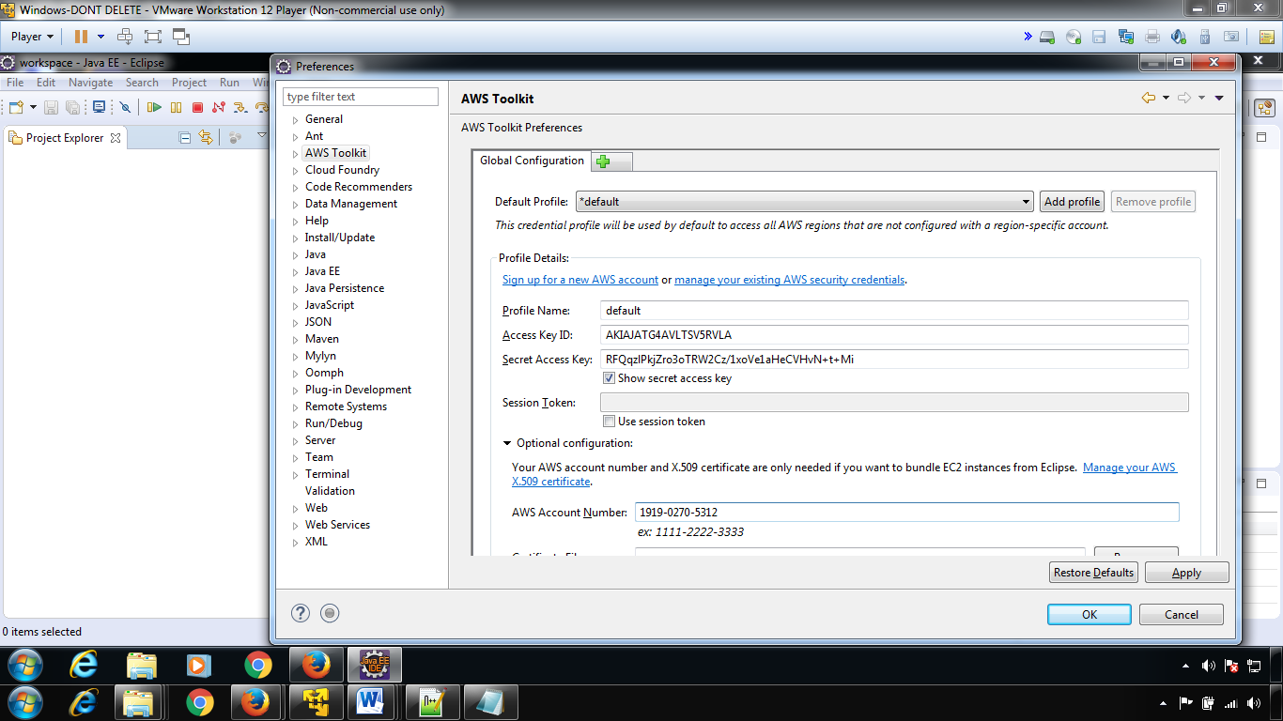

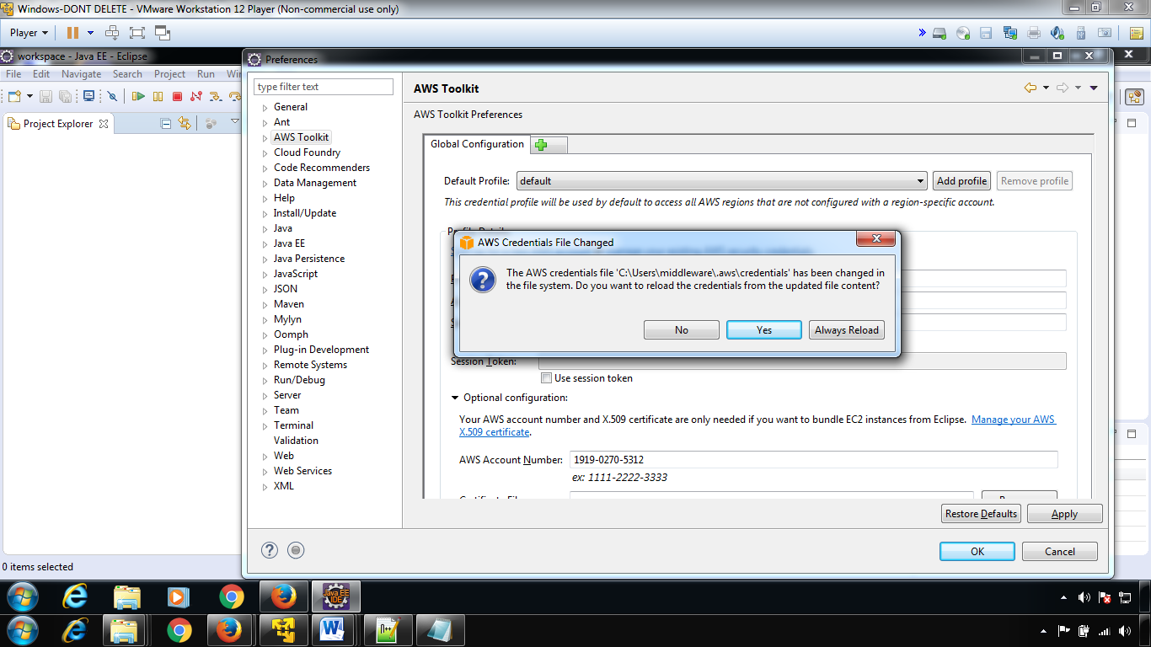

Click OK

**Step 4**

* Windows --> Show view --> Other --> Select AWS toolkit view (Select all views) --> OK
* Now you can see the perspective view of aws.

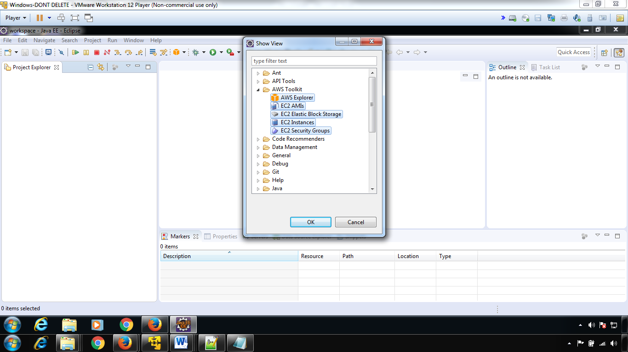

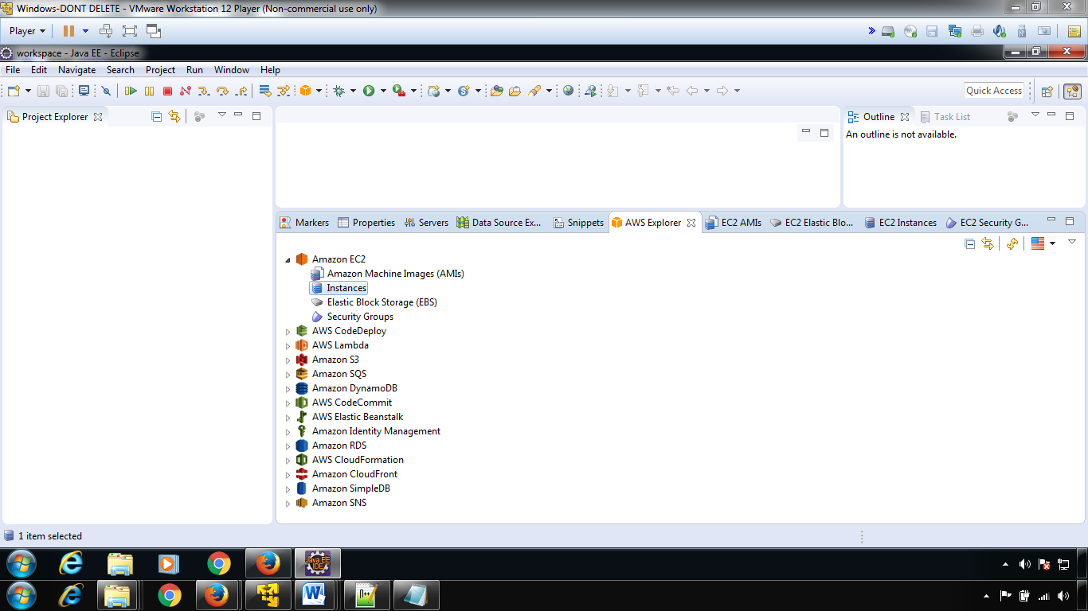

Configuration of aws with eclipse-done

**Step 4-**Creating an tomcat based environment

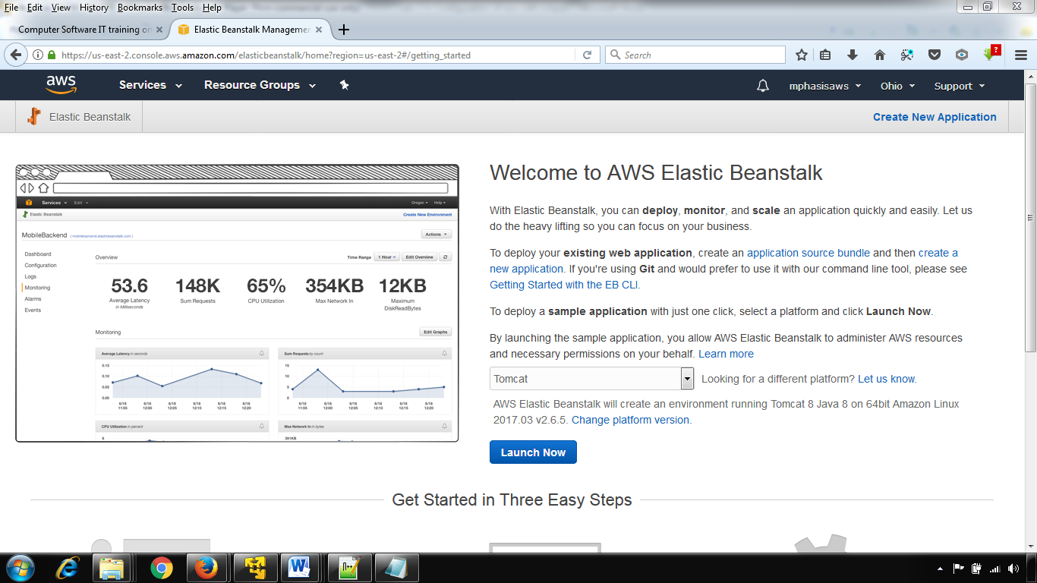

Select--🡪New Applications

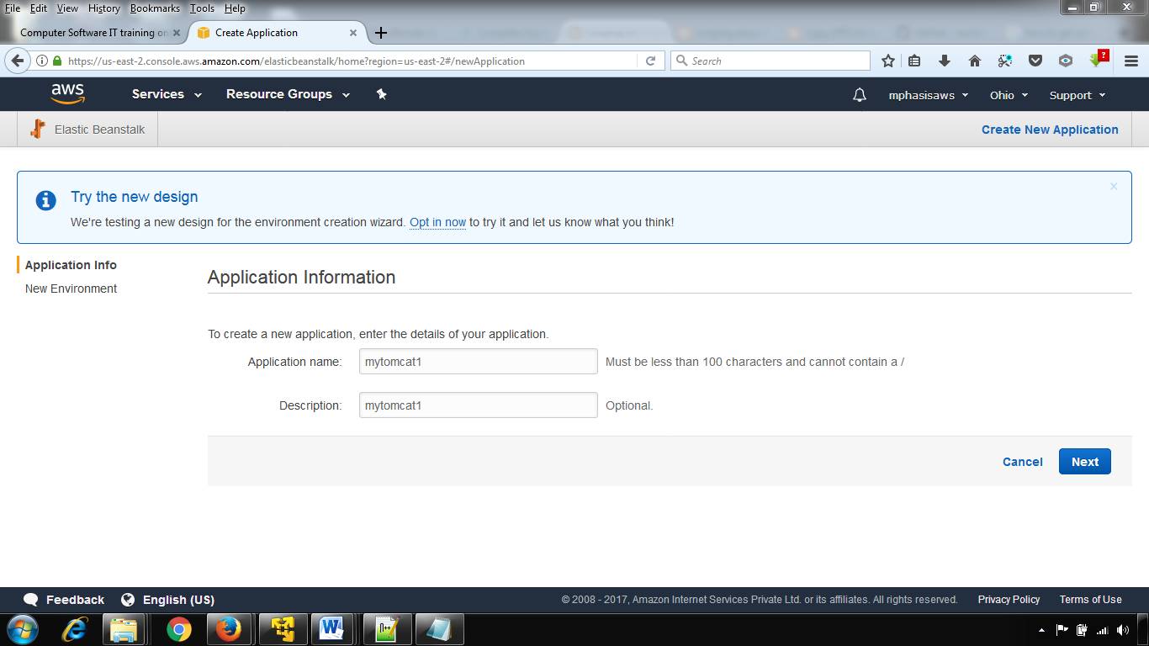

Select-🡪create a webserver environment

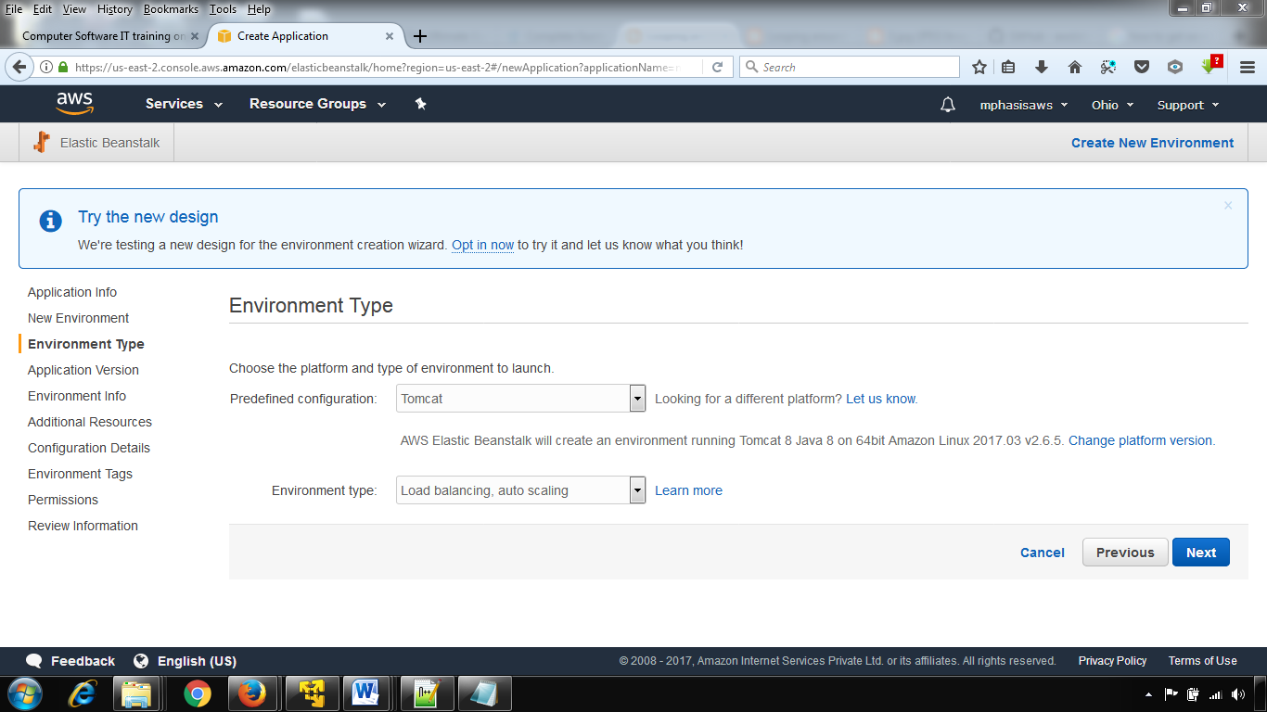

Just select Next

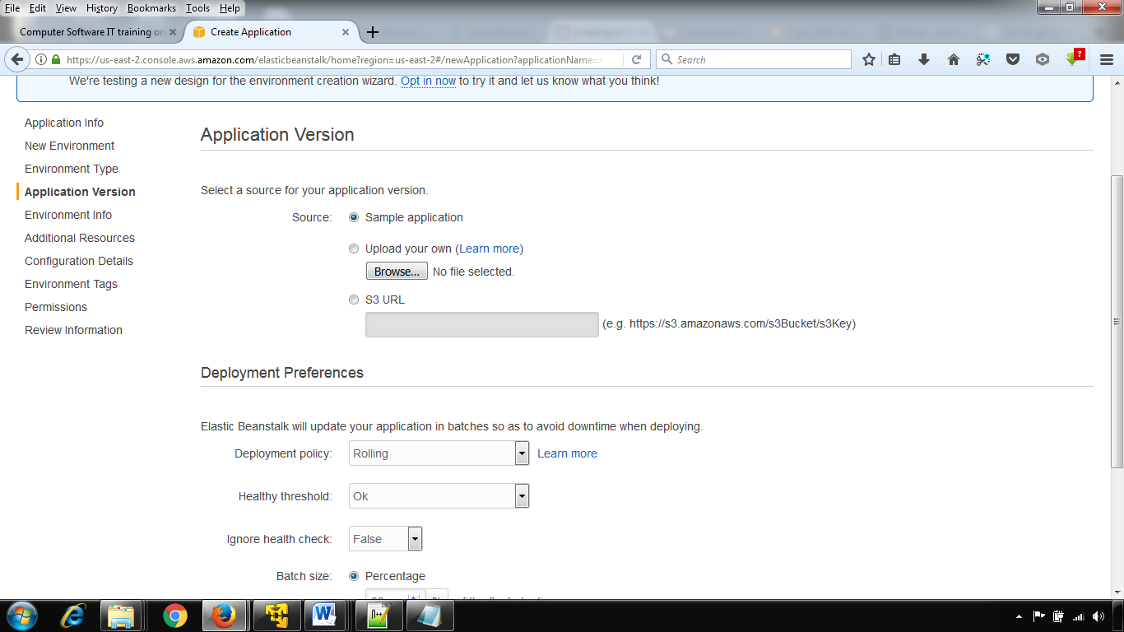

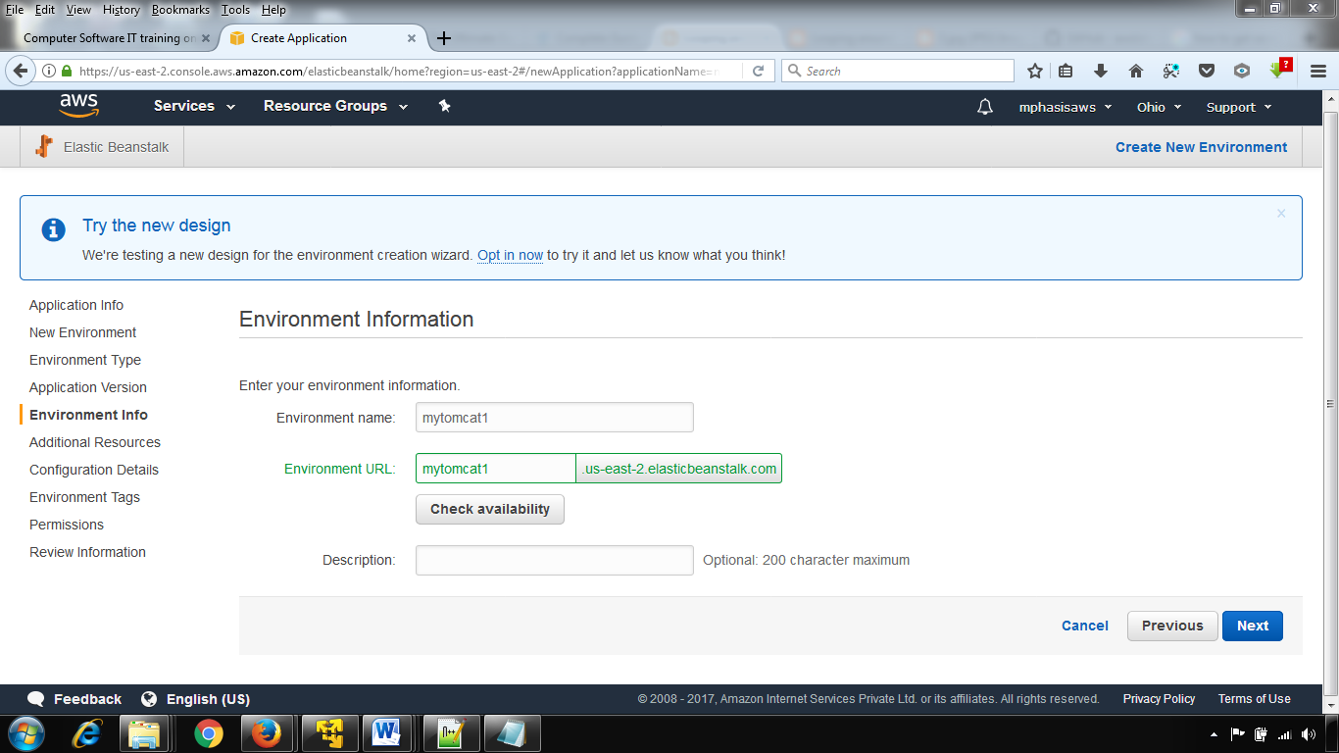

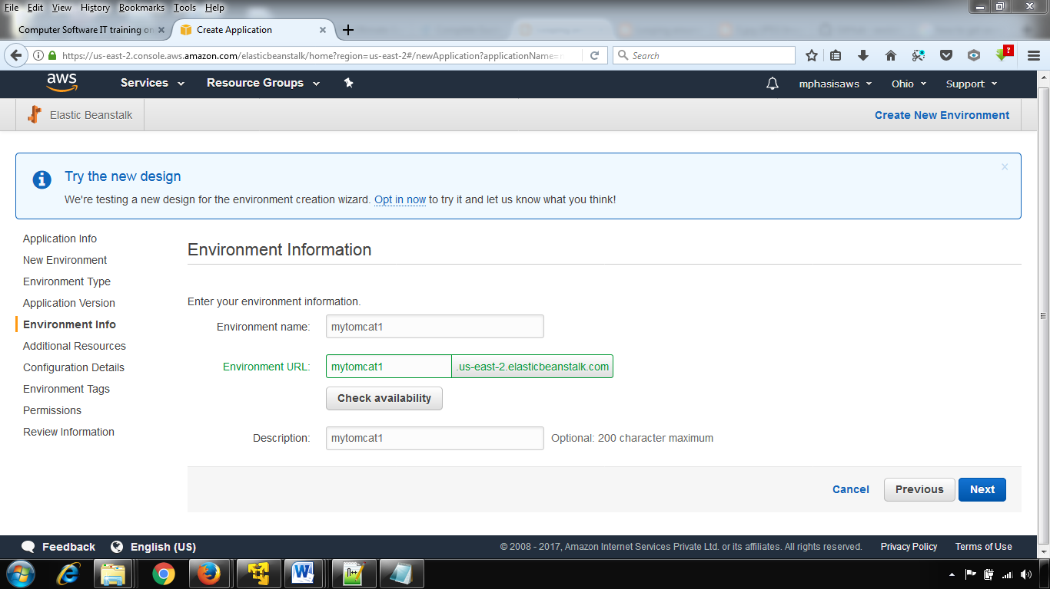

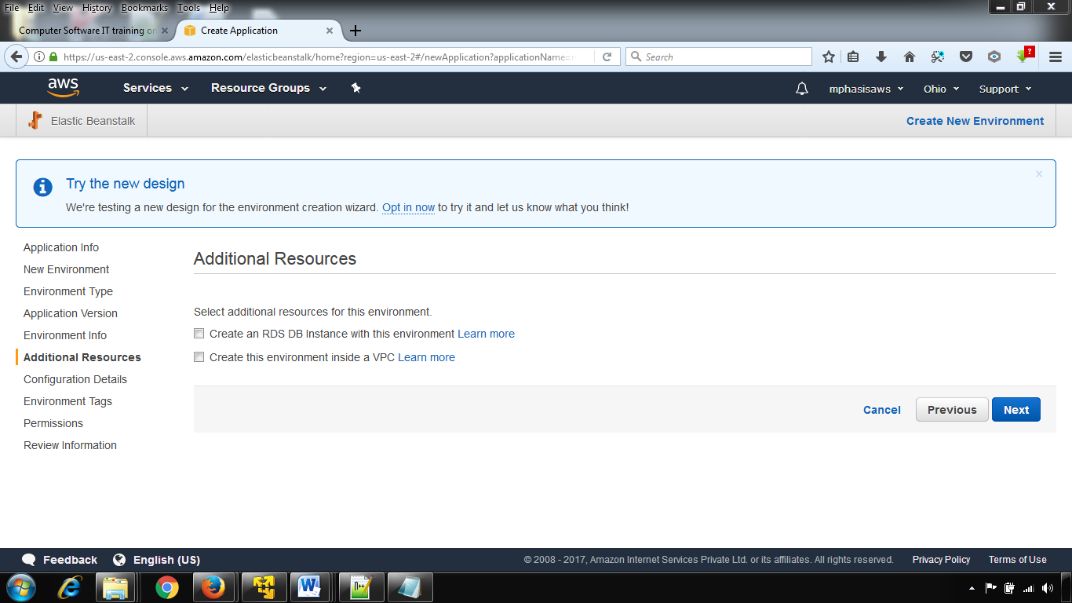

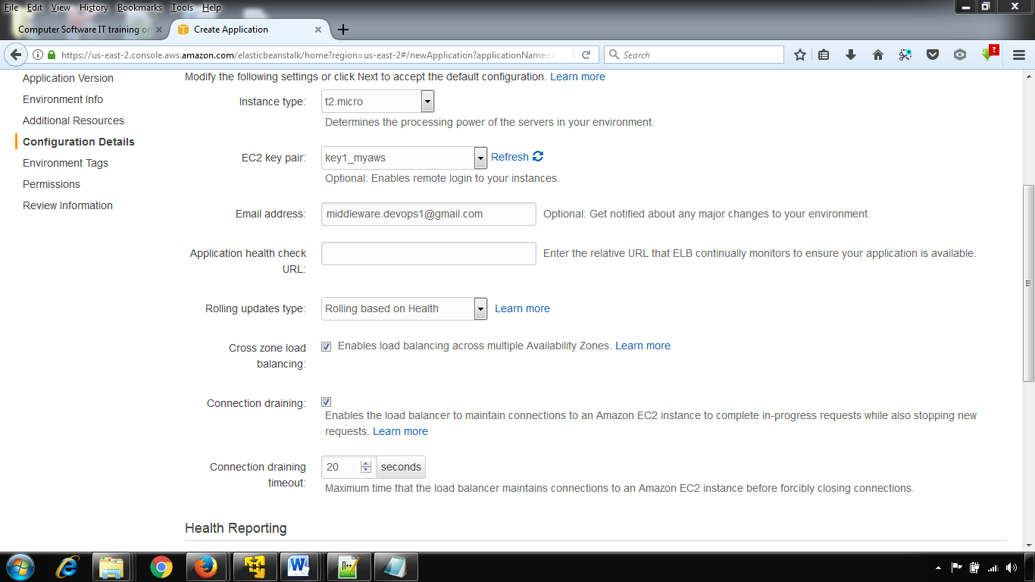

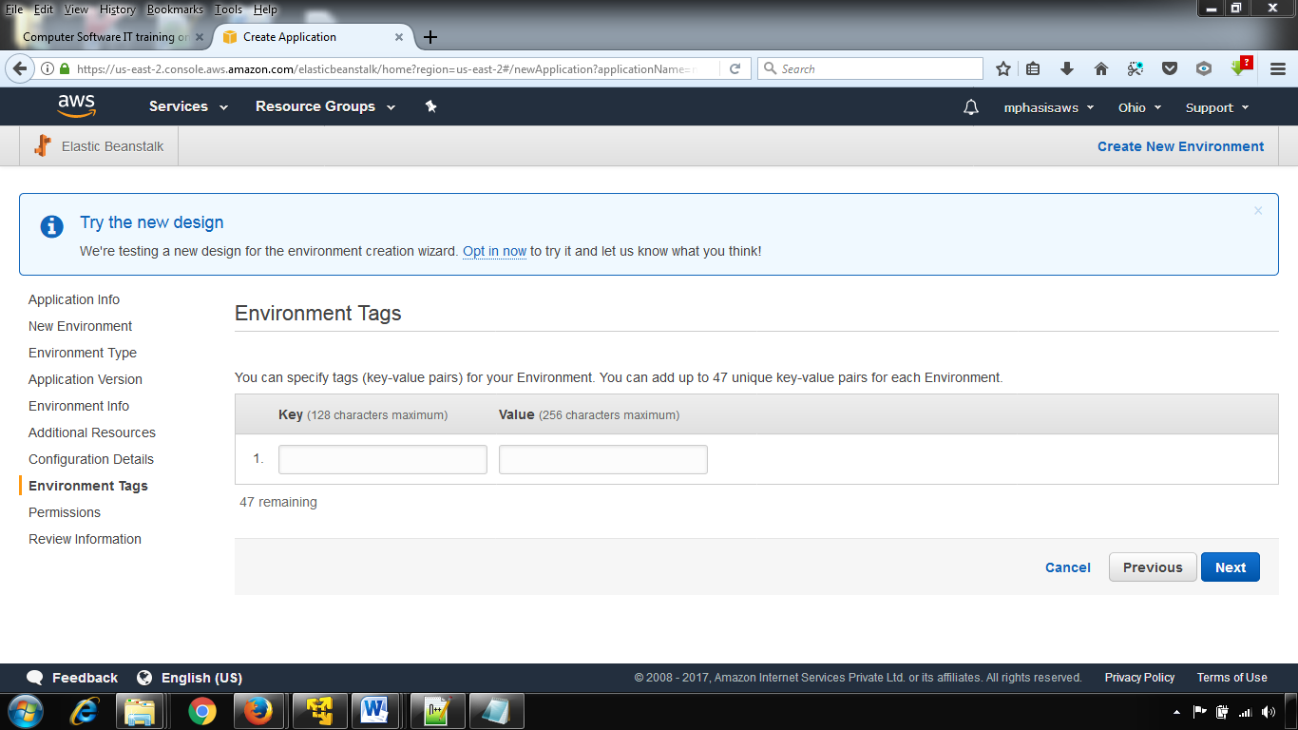

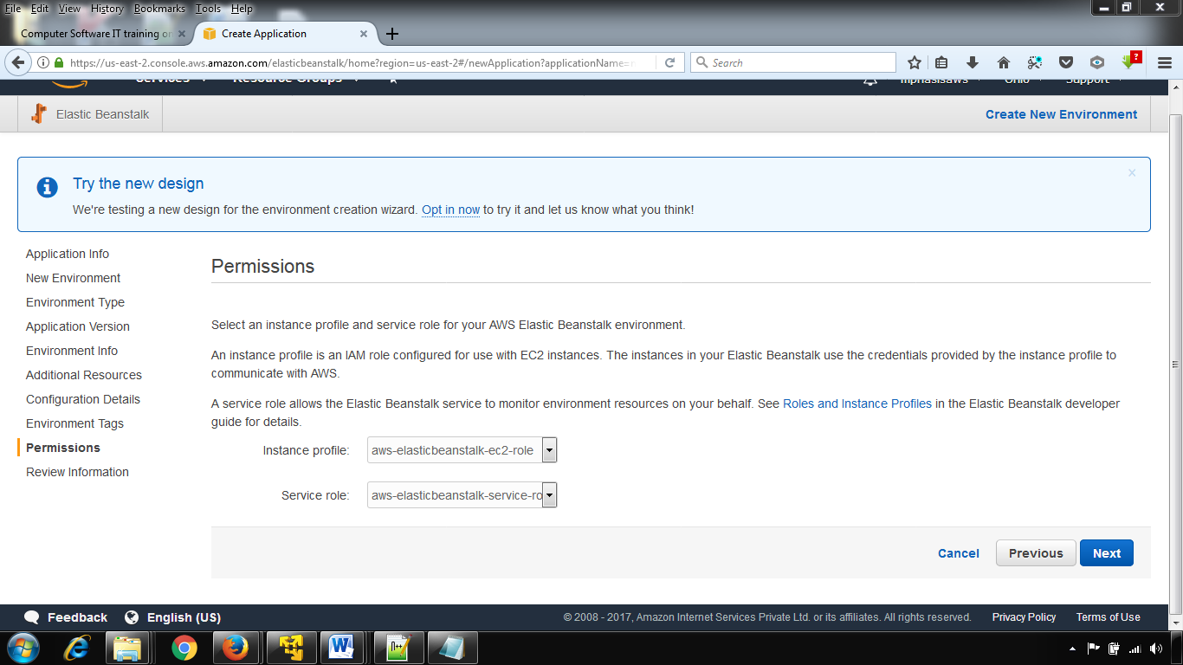

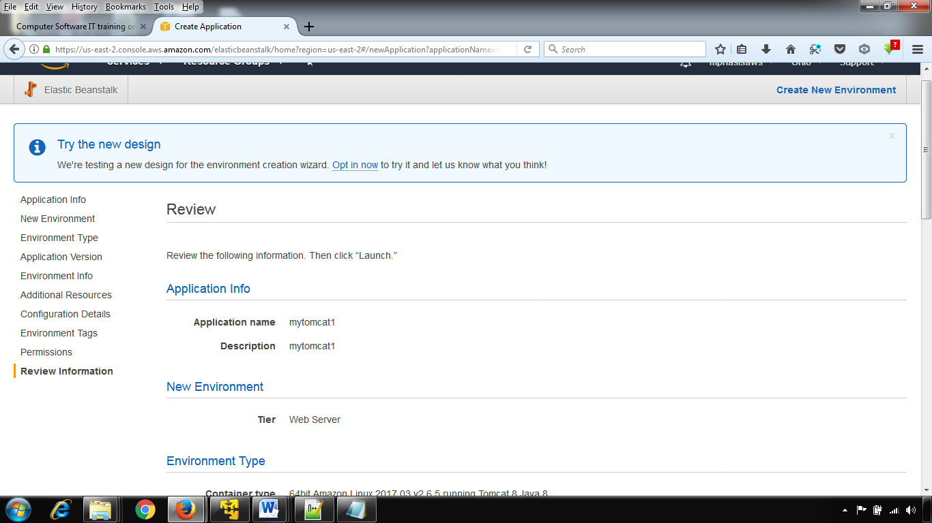

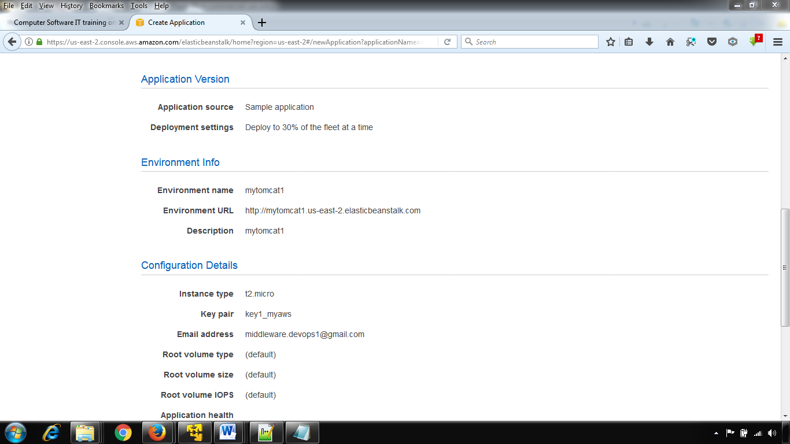

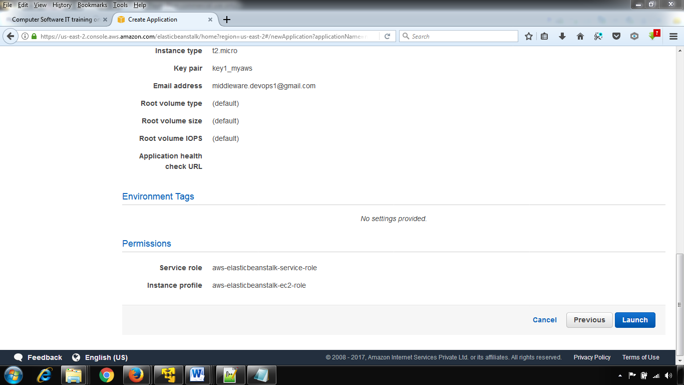

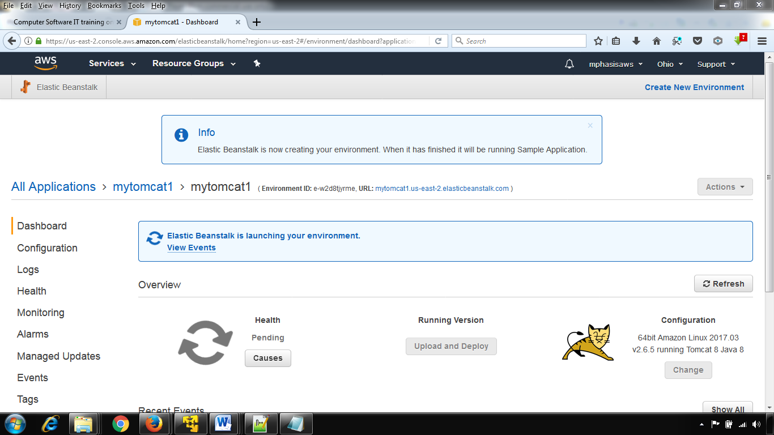

## mytomcat1 ****Environment ID:**** e-w2d8tjyrme, ****URL:**** [mytomcat1.us-east-2.elasticbeanstalk.com](http://mytomcat1.us-east-2.elasticbeanstalk.com)

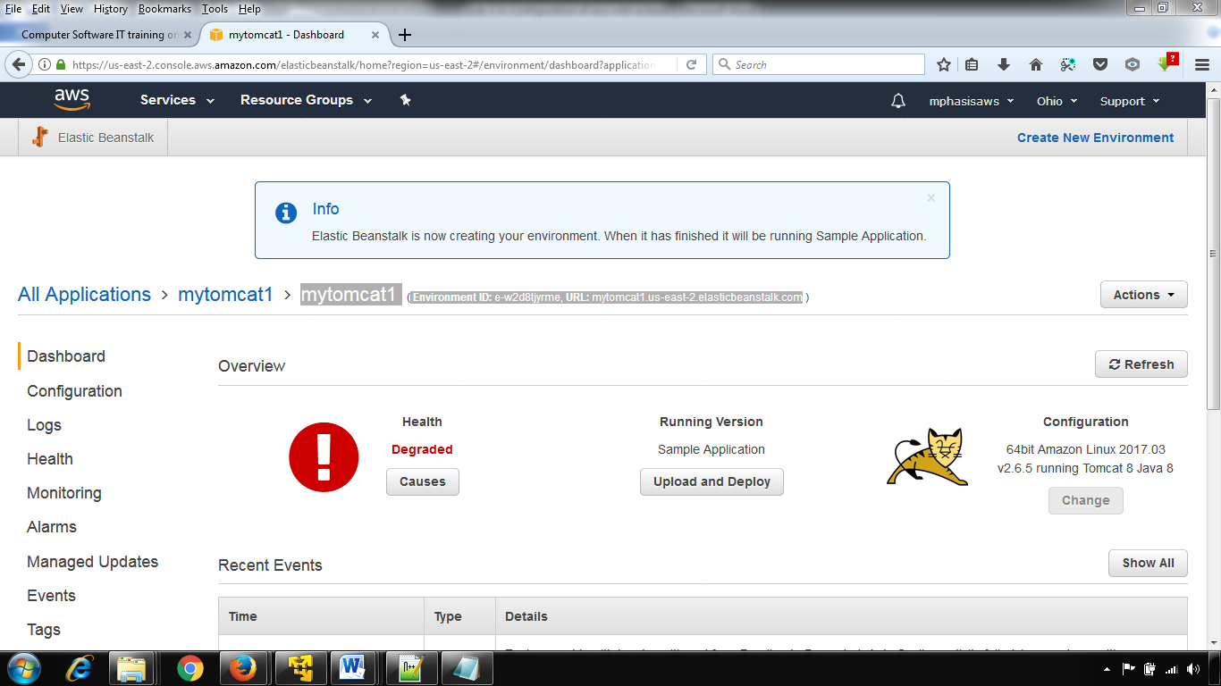

**Step-5**

* Now the configuration part is over.
* Lets create a Amazon ec2 server. To do that File --> New --> Other --> Server --> server  --> select amazon ec2 or amazon elastic server tomcat version 6 (you can either choose tomcat version 7)
* Fill the fields and Finish. (Hope you have some basic understand about eclipse)

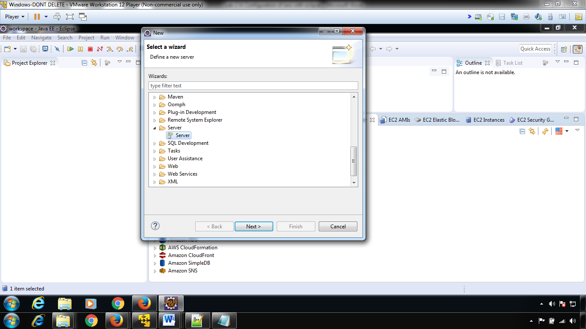

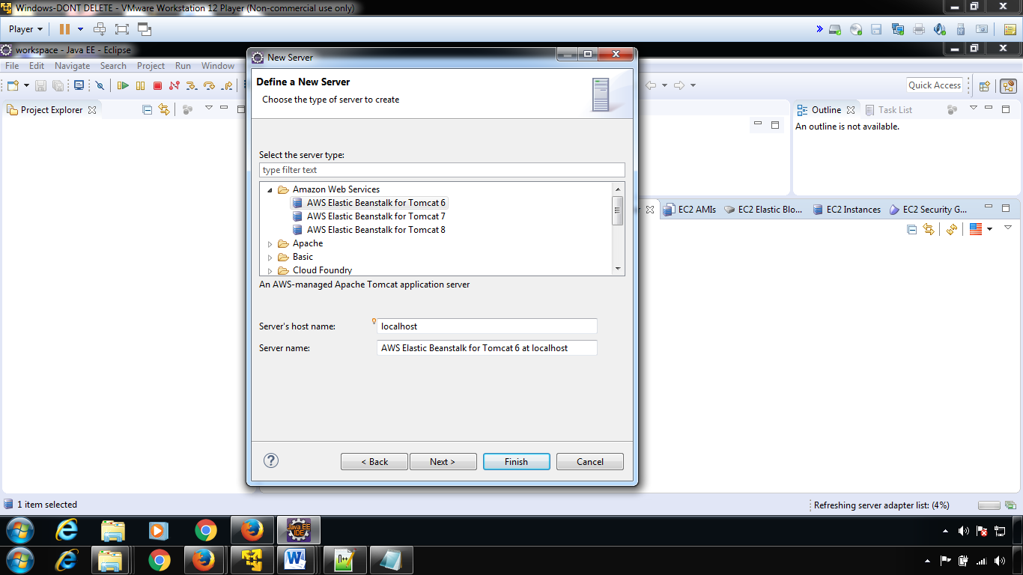

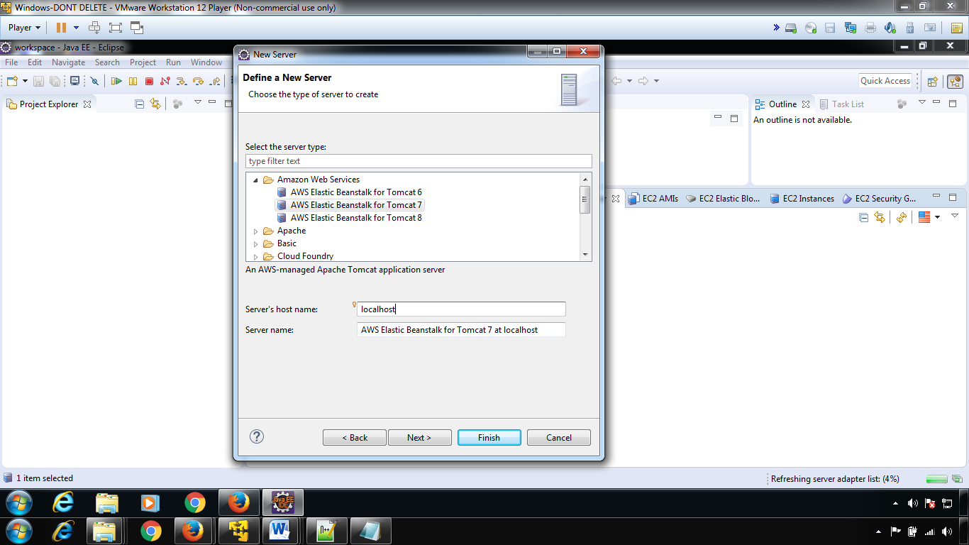

**Choose tomcat8 version only**

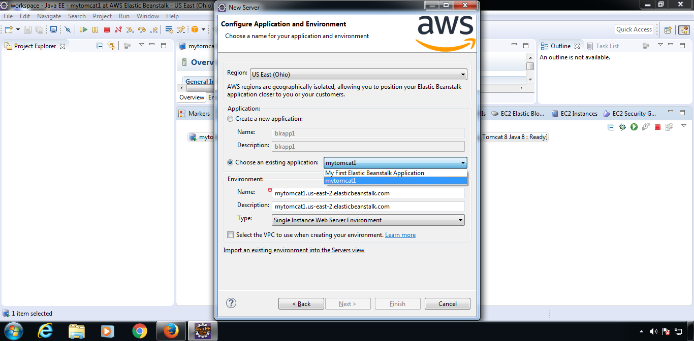

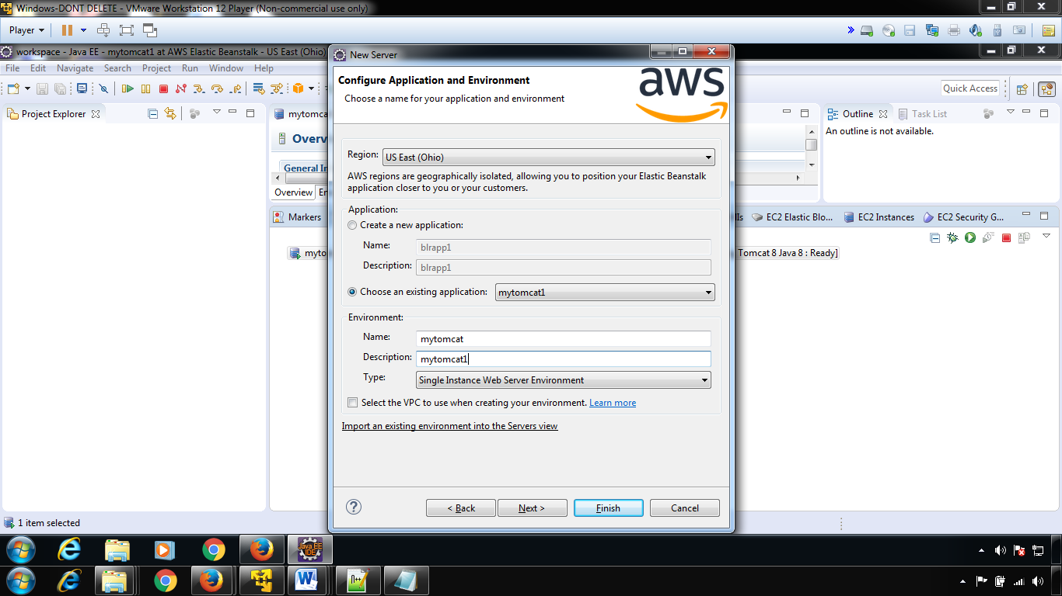

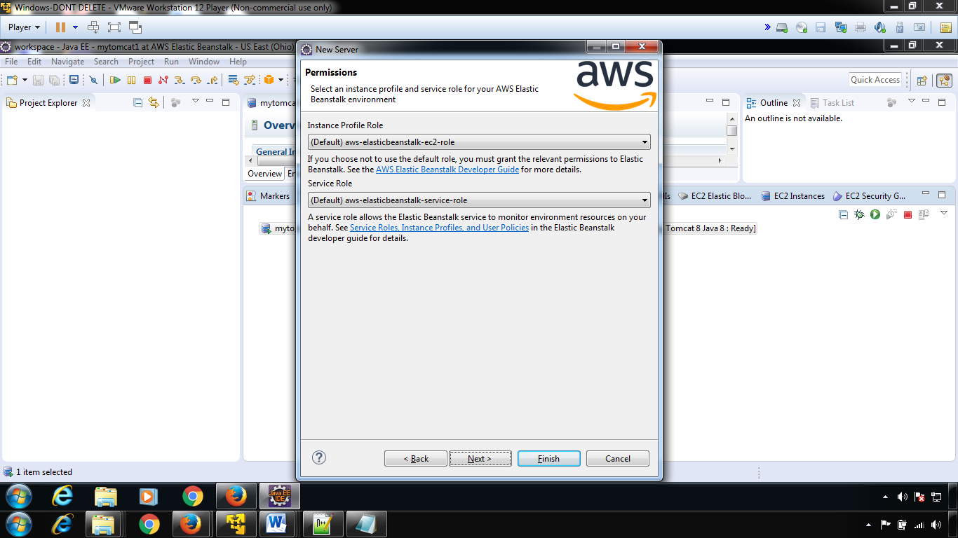

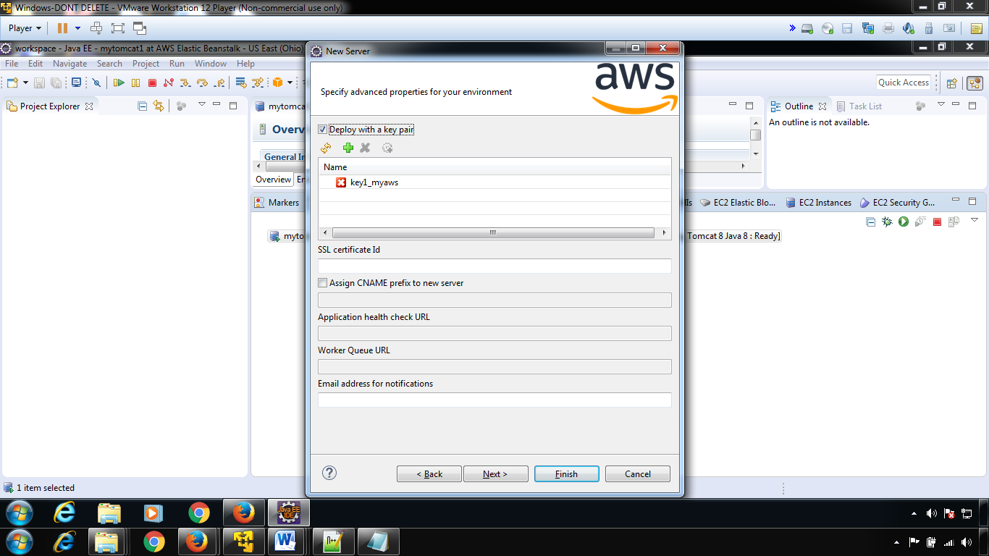

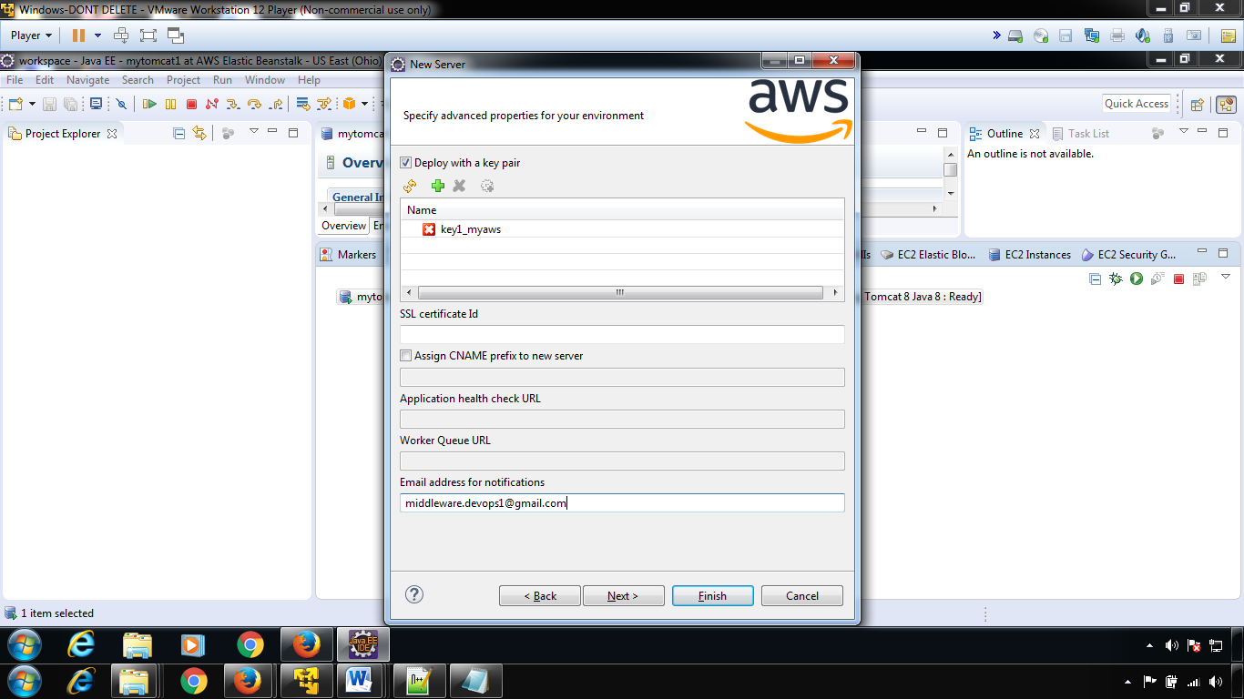

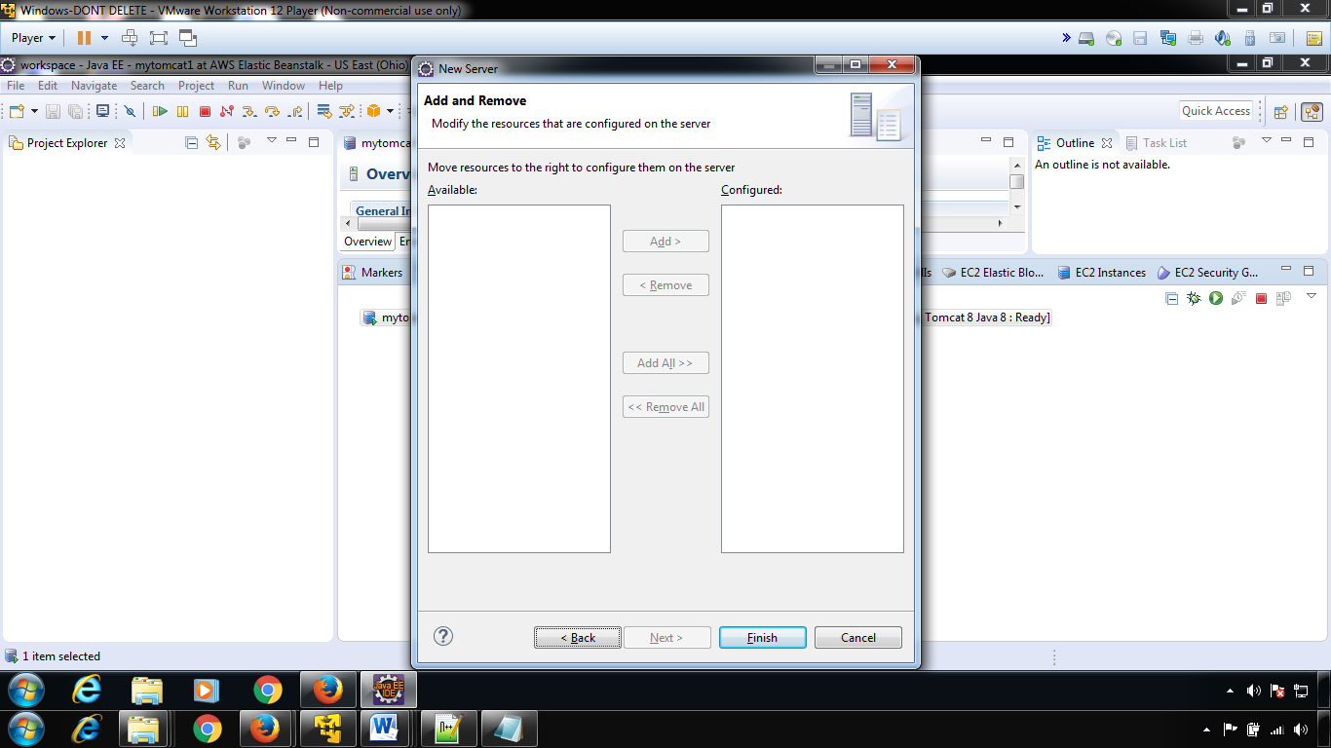

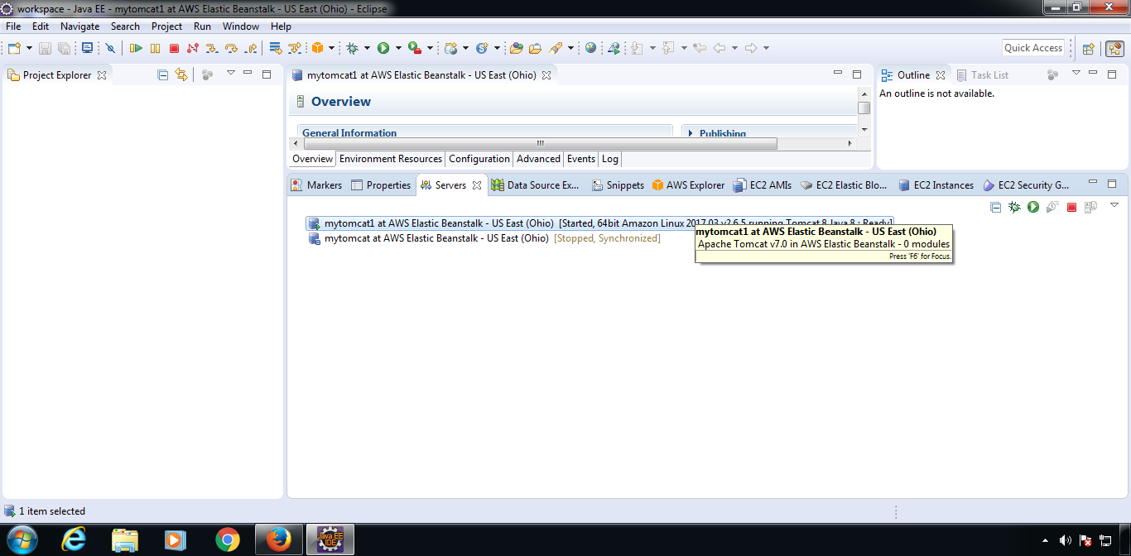

**Step 5**

* Now create a Dynamic Web project. File --> New --> Other -> Web --> Dynamic Web Project
* Give whatever name you like.
* Choose AWS Ec2 or Elastic runtime as a target runtime.
* Click Finish

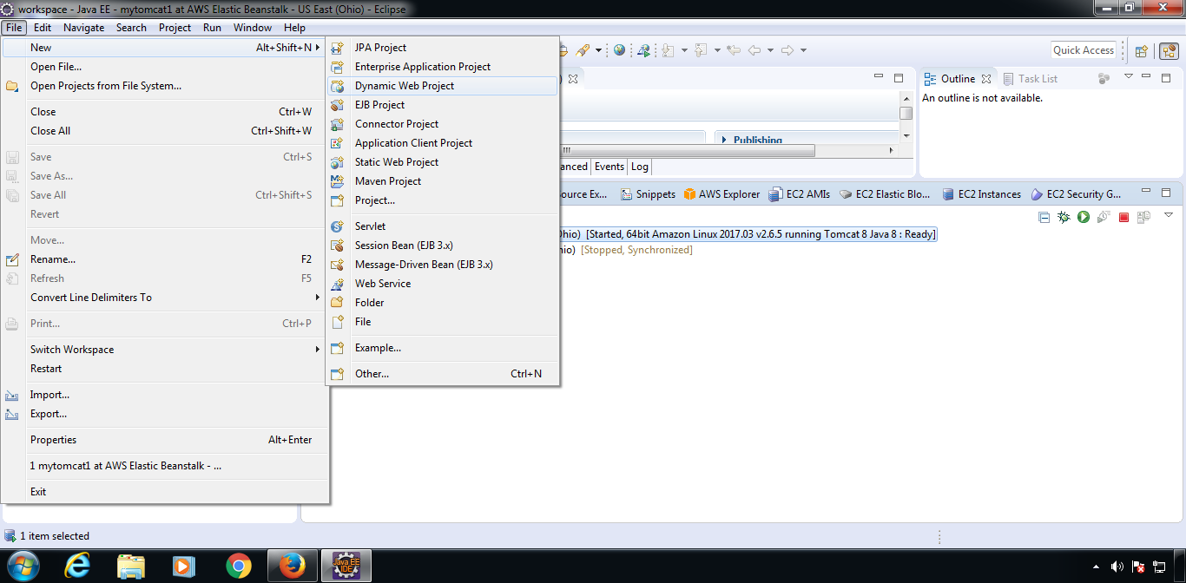

Give the appname+select new runtime

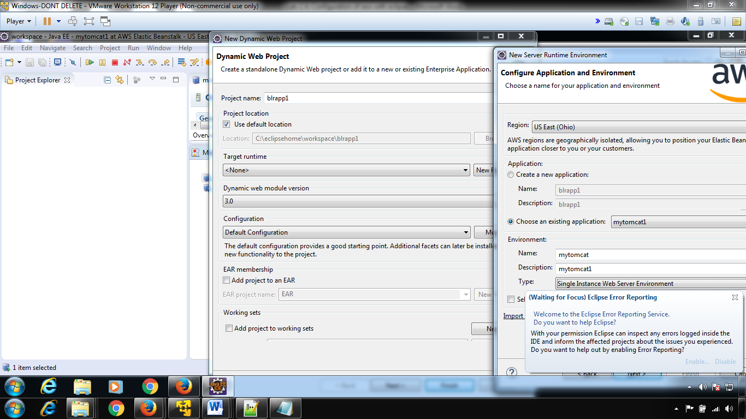

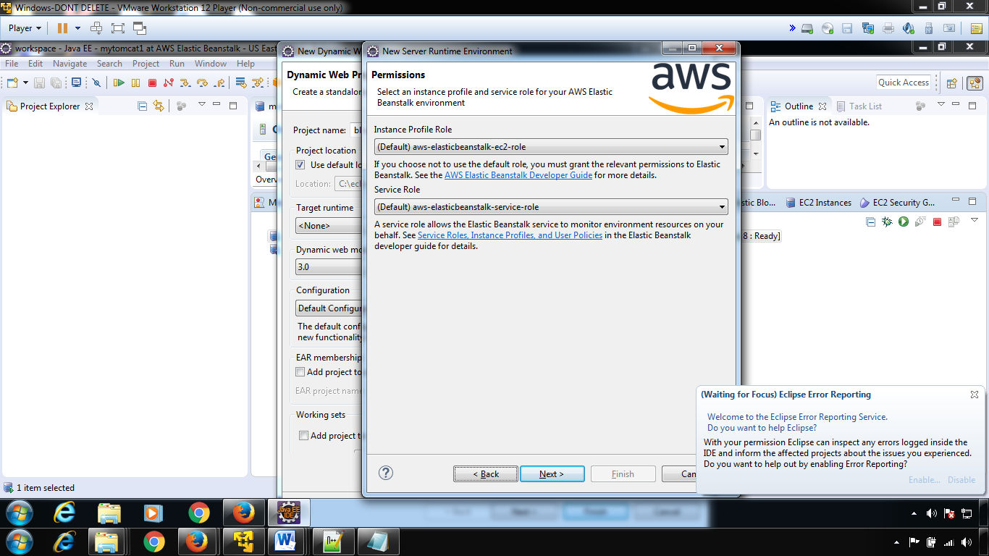

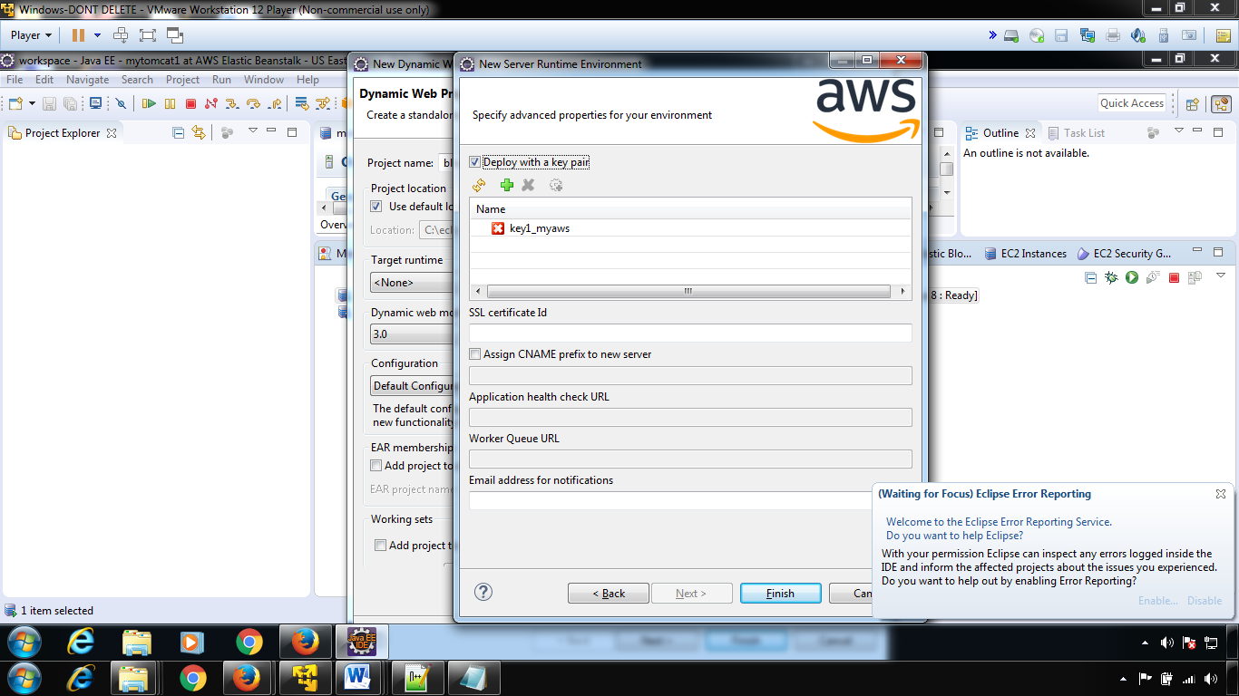

Check the above step—if its not happening—leave and create a dynamic web project

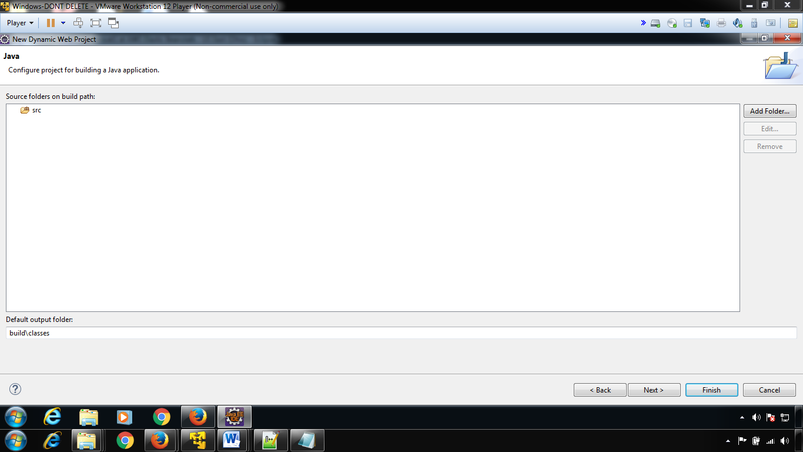

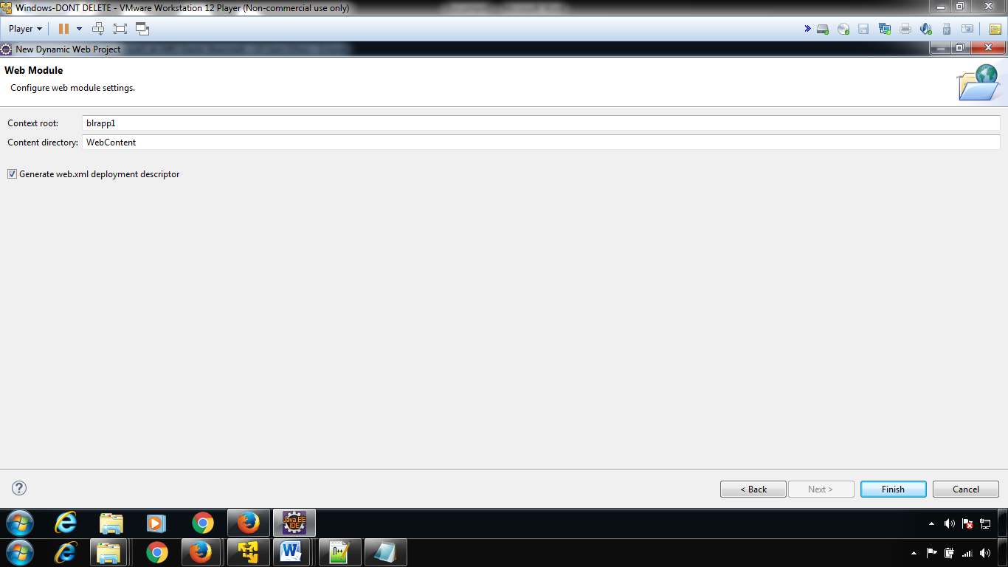

Project will be created

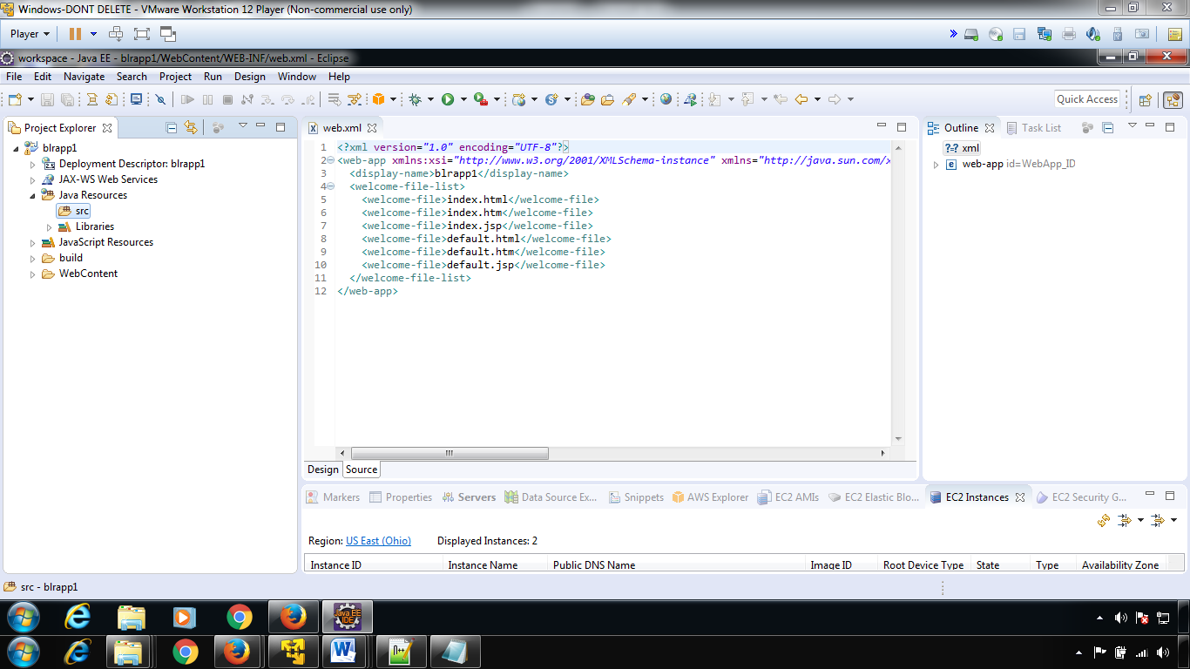

**Step 6**

* Now create a servlet and Finish
* Change the doGet() in servlet (Only for demo. This is where your code goesssss)

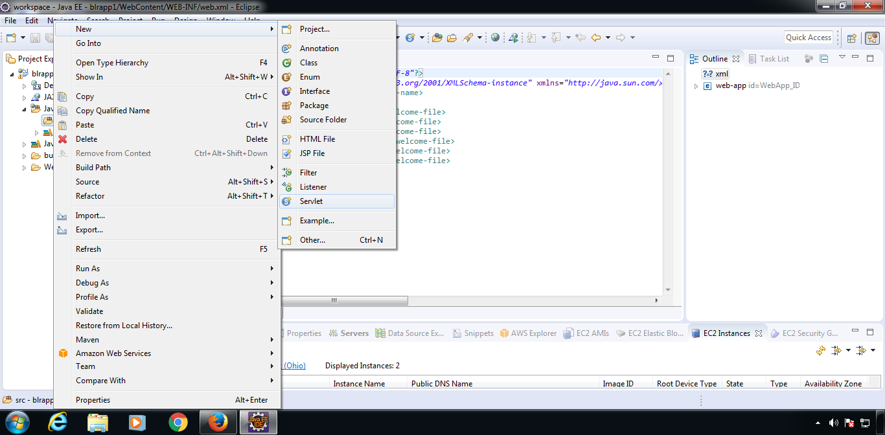

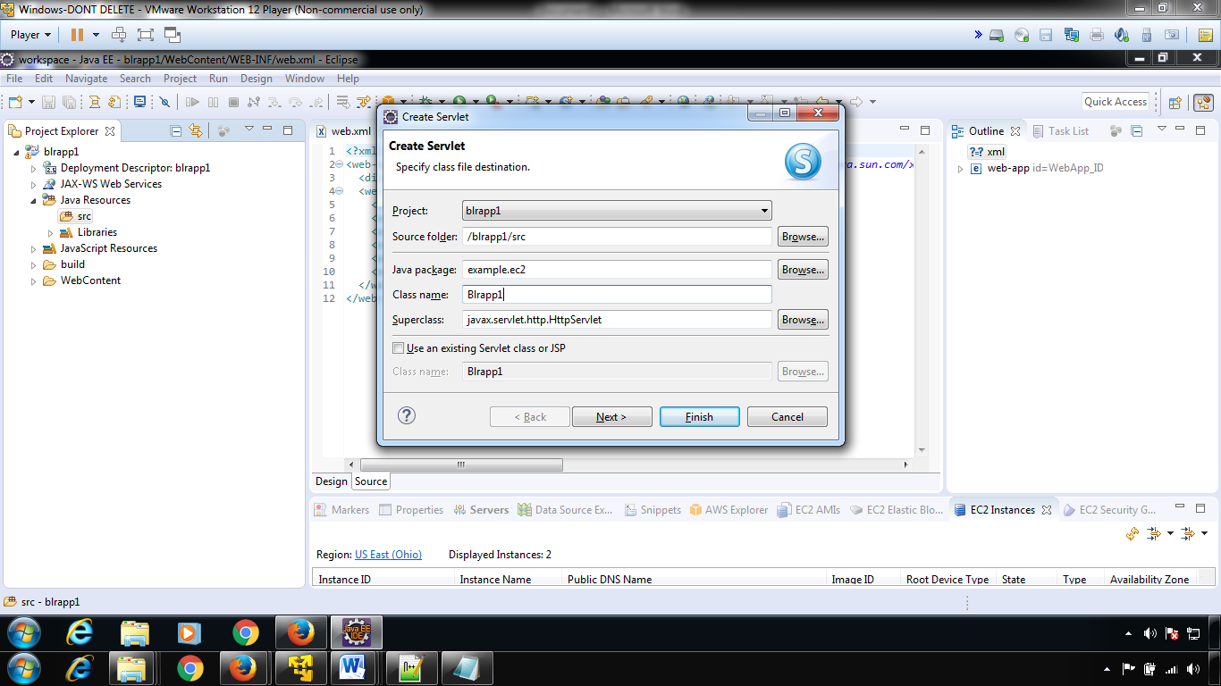

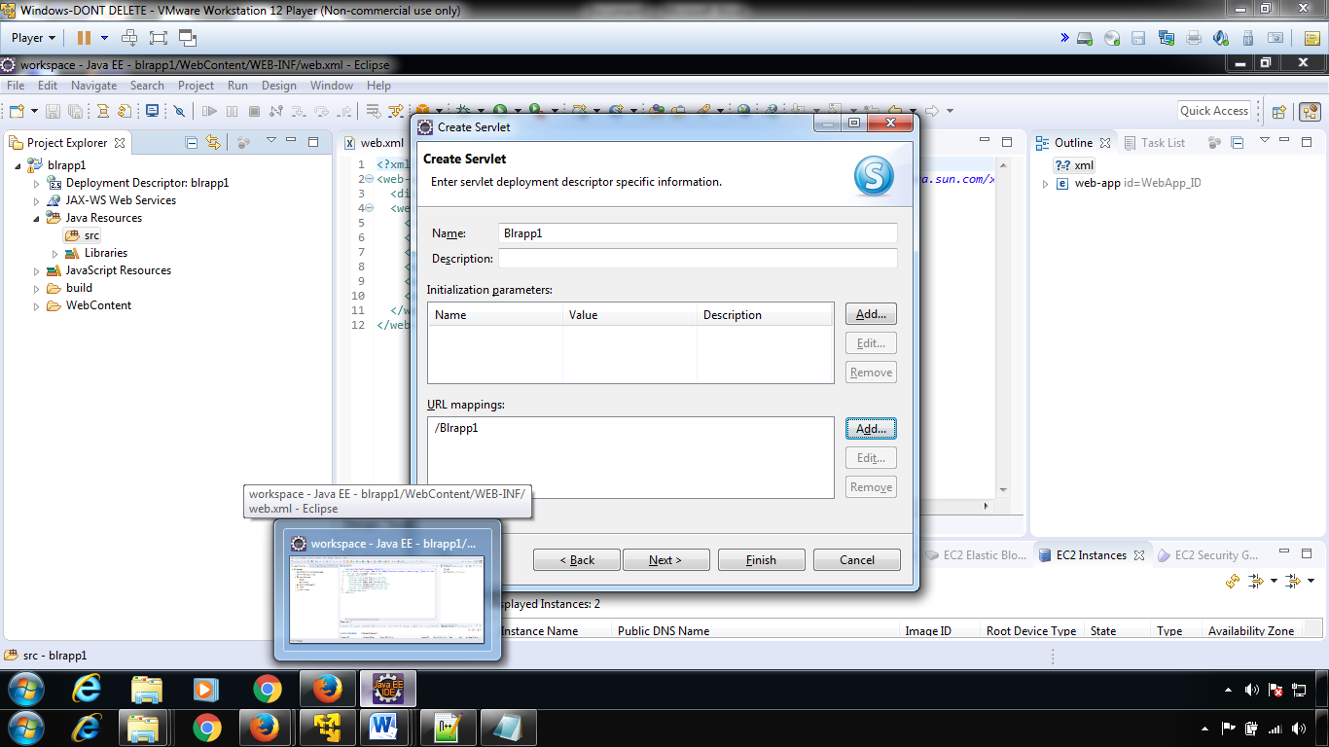

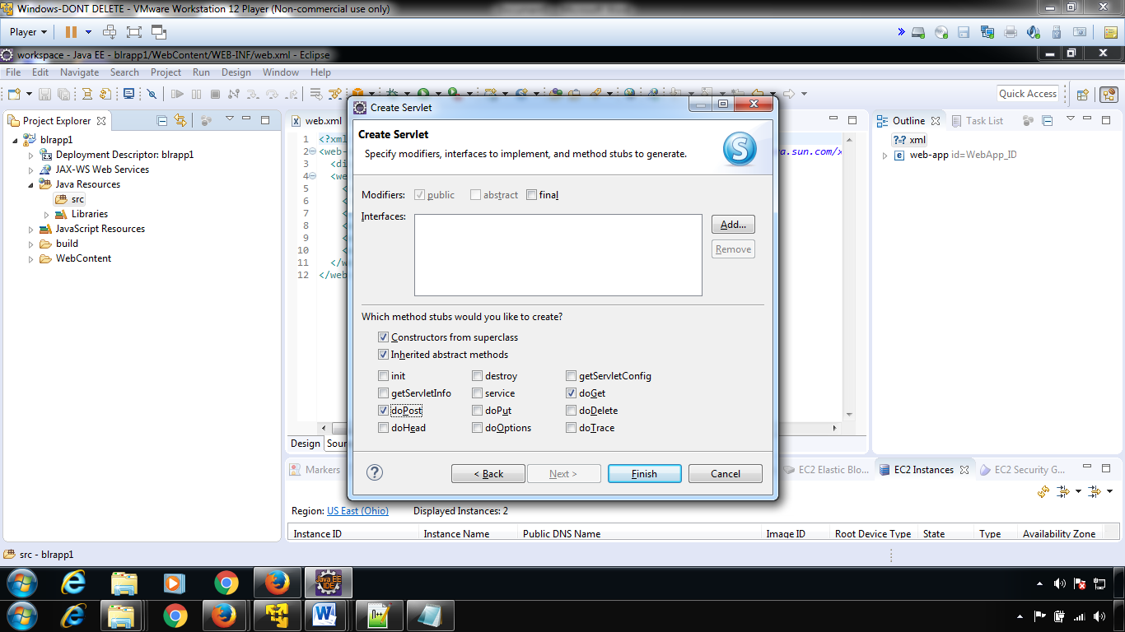

Click finish

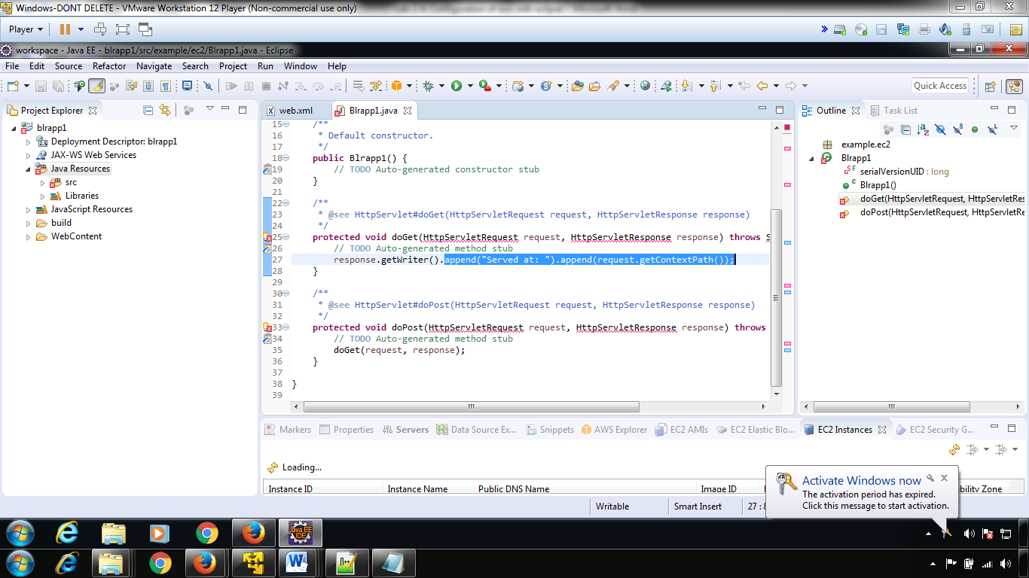

Just to test,lets add println(“welcome to bengalouru india”);

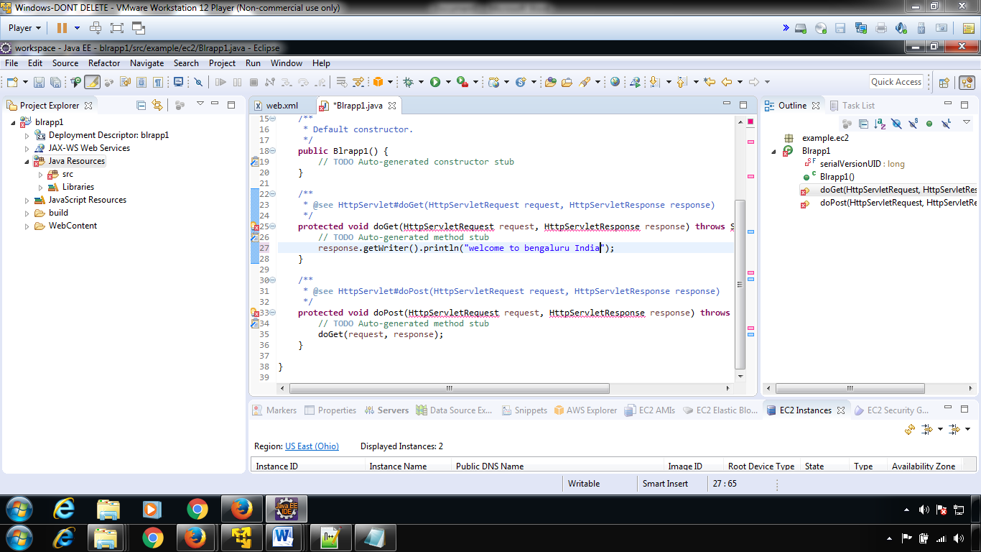

Remove this” append("Served at: ").append(request.getContextPath());”

**********check source

